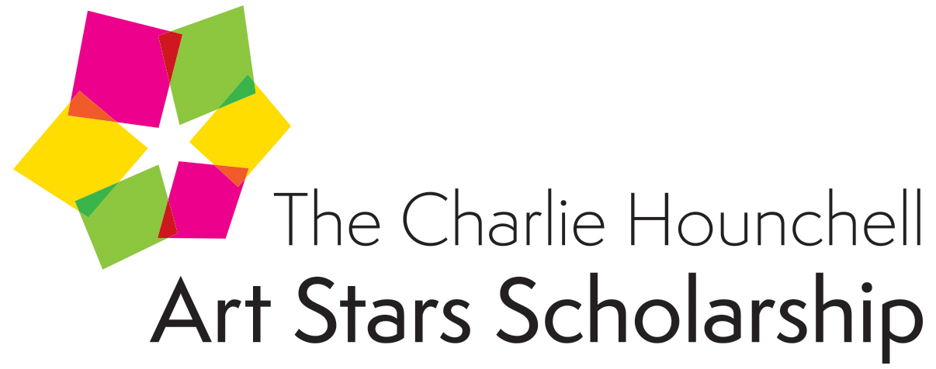

2018 CALL TO APPLICANTS NOW OPEN – APPLICATION DEADLINE Friday, february 23, 2018

Tampa Bay Businesses for Culture & the Arts (TBBCA) is accepting applications for the 2018 Charlie Hounchell Art Stars Scholarships. TBBCA Board Director and President, the late Charlie Hounchell, founded the scholarships program in 2007, to provide financial assistance to some of the most talented Tampa Bay area high school students for their continuing higher education in the arts. The Charlie Hounchell Art Stars Scholarships Program is open to qualified high school juniors and seniors in Hillsborough, Pinellas and Pasco counties. There is no fee to apply. Scholarships of $2,500 will be awarded in each of the following fine and performing arts areas: Dance, Theatre, Instrumental Music, Vocal Music Visual Arts, and Literary Arts. Awards are applied directly towards tuition expenses at the winner’s selected college, university or professional training program. Winners will be selected based on talent and merit by a panel of judges who are experts in their respective fields. For information on 2017 judges and CHASS recipients, see https://www.tbbca.org/programs-events/art-stars-scholarships/

To be accepted for judging, applicants must submit ALL of the following items by mail only as one package together to TBBCA P.O. Box 559, Tampa, FL 33601. Deadline is Friday, February 23, 2018. Students are encouraged to begin the application process early. Completed applications are accepted by mail to TBBCA at any time before the deadline. Application package should include hard copy completed and printed and signed application forms, recommendations and letter, together with applicant’s work samples on USB drive.

APPLICATION CHECKLIST – REQUIRED ITEMS
Application Forms – Applicant questionnaire, background information, future aspirations and artist statement as part of hard copy package.

Guidance Counselor’s Recommendation Form – Completed by guidance counselor or school administrator certifying grade point average as part of hard copy package.

Two Recommendation Forms – Recommendation forms printed and signed by the applicant’s arts teacher and from an adult that has known the applicant personally for two or more years and is not a family member as part of hard copy package.

Competitor’s Agreement –A consent form to be printed and signed by the Applicant and the Applicant’s Parent or Guardian as part of hard copy package.

Work Sample(s) – Submissions should demonstrate artistic talent and ability by submitting work samples video/audio recordings or word docs/images/photographs for Literary and Visual Arts on a USB drive clearly marked with the applicant’s name and address in the same hard copy application package. If applying for Literary Arts, please include USB drive AND hard copies printed of your work samples. Work samples will NOT be accepted separately from application package, or via email or other file sharing tool. If you have difficulty procuring a USB drive, please contact TBBCA. Please include Work Sample Form.

Photo – Please include a print quality headshot as a high resolution jpeg file on USB drive as part of package. (School photos are acceptable.)
DEADLINES

Application materials must be RECEIVED no later than Friday, February 23, 2018. Winners will be announced in April and will be honored and will showcase their talents at the 2018 Charlie Hounchell Art Stars Awards Ceremony in May.

MAILING & DELIVERY INSTRUCTIONS

Mailing Address: TBBCA P.O. Box 559, Tampa, FL 33601
Application materials MUST be mailed as ONE package, including hard copy printed and signed forms and USB drive for talent portion of the submissions (videos/ recordings/ images/ photos/word docs of work samples).
Word doc work samples hard copy should be printed (no handwritten).

When submitting application package material (hard copies and USB drive), include all materials in one package or envelope clearly labeled with the applicant’s name and address. Materials may be fastened with binder clips or paper clips. Please no 3-ring binders, folders, sheet protectors or staples. TBBCA is not responsible for lost, damaged or stolen mail. Mailing Address: TBBCA P.O. Box 559, Tampa, FL 33601 Applicants may NOT submit any files nor portion of applications electronically via email nor via file sharing tool .

NOTE: Application materials will not be returned and become the property of Tampa Bay Businesses for Culture & the Arts.

If any questions regarding the application or process please contact TBBCA at (813) 221-2787 or via email susanaweymouth@tbbca.org

Note: Application and adjudication is made, accepted and /or performed without regard to race, religion, color, national origin, sex or disability and any other prohibited discrimination as defined in Title VI of the Civil Rights Act of 1964, section 504 of Rehabilitation Act of 1973 or Executive Order 11246

2018 application form

(print out and return hard copy together with other required material in one same package via mail to tbbca – please ensure legibility of your letters and numbers)

Name of Applicant

Applicant's Age_____________ Date of Birth______________ Primary Telephone _____

Other Home/Cell Phone

Email Address

Alternate/Personal Email Address __________________________________________________

Residence Street Address ______

City Zip County

Name of School Applicant Attends

Current Grade Level: (circle one) 11 12

Name(s) of Parent or Guardian

Parent/Guardian Telephone Number

Address (if different from above)

Scholarship - Please indicate field(s) of entry.

Dance Instrumental Music Literary Arts Theatre Visual Arts Vocal Music

By submitting this application, I agree to the terms and conditions of TBBCA, its partners, and requirements of the Charlie Hounchell Art Stars scholarship. Terms and conditions are subject to change without notice. Both applicant and parent/guardian signatures required.

Applicant Signature Date

Parent/Guardian Signature Date

Applicant’s Background

Please answer the following questions to the best of your ability. Please limit your responses in this section to one (1) page, 12 pt. font.

- What is your past and present training? Please include location, instructors name(s) and number of years studied. Feel free to elaborate on any mentorships that have been particularly meaningful to you and your training.

- Do you have any additional hobbies or interests? Please list your extra-curricular activities. (Work, volunteer, clubs, sports, etc.)

- Please list any special awards or honors you have received for your art or other endeavors.

- Please list any special skills that are relevant to this application.

Future Aspirations
Please answer the following questions to the best of your ability. Please limit your responses in this section to one (1) page, 12 pt. font.

- What are your plans after high school (advanced training, college, future career plans)? Describe how this scholarship will help you advance these goals.

- Have you applied for or received any other scholarships? If so, which ones?

Artist Statement
Please write a first person statement that describes you and your art. Please limit your response to two (2) pages, 12 pt. font. Consider the following when crafting your response:

Who or what inspires you as an artist or performer, and how does this connect to your work? What drives you to create or perform? What does your art signify or represent? What is unique or special about your art, and what does it mean to you? Consider using this section to elaborate on your work samples and how they convey your inspiration as an artist.

GUIDANCE COUNSELOR RECOMMENDATION
To be completed by applicant’s guidance counselor or other school administrator.

Please indicate the applicant’s current grade point average.

School Name
Student Name
Grade point average for school year
Comments (May be left blank with no detriment to this application.)

Name
Title

Signature Date

RECOMMENDATION FORM
To be completed by arts teacher.
Please answer the following questions in the space provided.

- How long have you known the applicant and in what capacity?

- Why do you believe the student will be successful in his/her continuing education and/or in a fine or performing arts career?

- What is your assessment of the applicant’s abilities in his/her respective arts area? Please write down the appropriate response with the following words: Unable to observe, Average, Good or Superior.

Self-discipline:

Level of artistic growth:

Commitment to artistic growth:

Creativity:

Concentration:

Maturity:

Accepts Criticism:

- Are there unique factors or additional comments that make the student especially worthy of receiving scholarship support (talented, self-directed, etc)?

Name
Title

Signature Date

RECOMMENDATION FORM
To be completed by an adult who is not a member or relative of the applicant’s family.
Please answer the following questions in the space provided.

- How long have you known the applicant and in what capacity?

- Why do you believe the student will be successful in his/her continuing education and/or a performing arts career?

- Are there unique factors that make the student especially worthy of receiving scholarship support (talent, self-directed, etc.)?

- Additional Comments:

Name
Relationship to Student

Signature Date

COMPETITOR AGREEMENT

All competitors who reach the finals agree to make no less than one and no more than three appearances on behalf of the Tampa Bay Businesses for Culture & the Arts (TBBCA) and The Charlie Hounchell Art Stars Scholarship at no cost to the program. Students who are awarded the scholarship are required to write a letter of acceptance including what the scholarship means to them and to give updates of their educational pursuits in the arts on a yearly basis and/or upon request of TBBCA.

RELEASE FOR USE OF LIKENESS, RECORDING OR INFORMATION
As parent of or legal guardian of the minor named above, I give to the Tampa Bay Businesses for Culture & the Arts, its nominees, agents and assigns, unlimited permission to use, publish and republish in the furtherance of its work, reproductions of the likeness, photographic or otherwise, the voice, and the above information, with or without use of the name, of the above stated individual.

Parent/Guardian Signature Date

Applicant Signature Date

Work Samples

This application must be accompanied by work samples that serve as evidence of the applicant’s artistic skills and talents.

Requirements by discipline are as follows:

Dance - Audition videos not to exceed 7 minutes in length may feature classical ballet, contemporary, ethnic, hip hop, jazz, lyrical or modern dance. Recordings must be submitted on USB drive.

Instrumental Music – Audition recordings not to exceed 7 minutes in length may feature brass, percussion, woodwind or string solo performances. Please no electronic instruments. Recordings must be submitted on USB drive.

Literary Arts – Acceptable work samples include short stories, poetry, screen or stage plays or other forms of creative writing. Works are to be submitted (word format) on USB drive and as well as in hard printed (not handwritten) copy.

Theatre – Audition videos not to exceed a total of 7 minutes in length should include at least one monologue and one additional performance excerpt in a varying style. The second piece could be a monologue, song or a dialogue between two actors. If a dialogue is included, please clearly identify both actors. Videos must be submitted on USB drive (must be bubble wrapped).

Visual Arts – Images of artwork may be submitted on USB Drive (jpg or pdf formats preferred). High resolution photographs are also accepted with hard copy applications.

Vocal Music – Audition recordings not to exceed a total of 7 minutes in length should include two pieces of varying styles. Recordings must be submitted on USB drive (must be bubble wrapped).

Please note: At the beginning of each recording, the applicant should clearly state his or her name, the scholarship for which he or she is applying, the name(s) of the pieces being performed and the playwright, composer or choreographer. Recorded segments of public or school productions or performances are not permitted. It is recommended that USB submissions be reviewed by the applicant to ensure the performance has been successfully recorded.

All submissions become the property of the TBBCA and will not be returned.

WORK SAMPLE FORM

(Required to be completed anad included with work samples.)

Name of Applicant

Artistic Discipline

Please indicate work sample format(s).

USB drive Hard Copy Writing Samples Photographic Images

Audition recordings should not exceed seven minutes in length.

Please provide a detailed list of all Work Samples, including titles, authors, choreographers, mediums, etc.

1.

2.

3.

4.

5.

6.

7.

8.

9.

10.

